What was life like in the trenches of WWI?

1. What do you already know about the life of a soldier in the trenches of WWI? Go to mentimeter.com, and share your knowledge.

2. What was life like in the trenches of World War I?

Answer the following questions while watching the video:

1. What did the soldiers do to record their experiences?
__________________________________________________________________________________________________________________________________________________.

2. What caused the disease called “trench foot”?
__________________________________________________________________________________________________________________________________________________.

3. How large were the rats in the trenches?
______________________________________________________________________
_________________________________________________________________________.

4. What is one of the symptoms of “shell shock”?
__________________________________________________________________________________________________________________________________________________.

5. What was the most dreaded order a soldier could be given?
__________________________________________________________________________________________________________________________________________________.

Questions to be answered afterwards:

6. How has or hasn’t what you thought life was like in the trenches changed after watching this video?
_________________________________________________________________________
_________________________________________________________________________.

What was the same? What was different?

Read the following text and answer the questions

As you’ve just heard and seen in the video, the scariest and most dangerous thing about life in the trenches is having to go over the top into no man’s land. No man’s land was covered in dead bodies, wounded soldiers, and barbed wire. In addition to this you would also be exposed to enemy fire (gas, snipers, etc.).

Some soldiers even injured themselves so they wouldn’t have to go over the top. However, there were also some soldiers who went over the top without being commanded to do so.

Question to answer before reading the newspaper extract:

1. Why do you think anyone would go over the top without being asked to?
__________________________________________________________________________________________________________________________________________________
__________________________________________________________________________________________________________________________________________________.

Read the newspaper extract below and answer the questions.

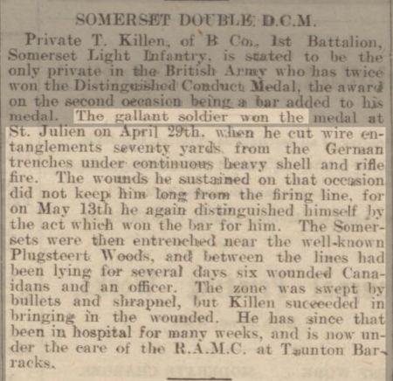

1. What is a DCM award? You may use the internet to look this up
__________________________________________________________________________________________________________________________________________________.

2. Why was private T. Killen awarded a Distinguished Conduct Medal?
____________________________
3. Why did this private receive a bar?

4. Considering the dangers of being in no man’s land, why do you think he would’ve risked his life (see question 3)?

5. If you were in the same situation,why would or wouldn’t you have risked your life to save others? (explain why)

- A letter to your family and friends about your life in the trenches

-Imagine you were a soldier living in the trenches of world war one. Every so often you get to write a letter to a your family and friends about your life in the trenches. Which (positive) experiences or other nasty things would you want to write about?
Write a letter (150-250 words) to a family member or friend of your choice in which you explain what your life is like in the trenches.

*You can think about the food, rats, diseases, mud, no man’s land, etc.
*Make sure you include your own opinion of what you think about living in the trenches.
*Talk about your scariest experience since living in the trenches.

For inspiration you may take a look at several ‘real’ letter written by soldiers on the front:
http://www.nationalarchives.gov.uk/education/resources/letters-first-world-war-1915/
Dear_________________,
June 15th 1915
Lots of love,

